WOLF VALLEY
NEWS

December Edition
2021

Welcome to the new Wolf Valley News!

A Very Merry Christmas to everyone!

This news sheet is supported by your Parish Council for Germansweek and Eworthy and covers those areas and beyond.

All are welcome to be involved. Please send your copy to the editor, details here and on the back page.

We hope to include all events locally, some advertising and all upcoming events along with ideas, suggestions, jokes. Please send us all that helps and encourages the community.

Regular contributors will be from the Vicar, the Parish Council and local clubs.

Copy deadline is the 25th. day of the month for inclusion in the next month’s issue.

Paper copies to be found in Germansweek Telephone Box, Outside the Dairy in Germansweek, Eworthy Telephone Box (formerly the Scone Box). Online at www.germansweekpc.co.uk or contact: wolfeditor@icloud.com

Germansweek Parish Church:

Message from the Reverend:

There have been rumours of Christmas being cancelled this year because of Covid, fuel shortages, food shortages, power cuts and whatever else the media rumour mill can churn out. I can't see how Christmas can really be cancelled after all it's a celebration of the birth of Christ, I suppose they mean the commercial Christmas, the one that starts in the middle of October and finishes on Boxing Day. That might not be a bad thing if it meant we didn't have to endure endless, tacky, tinselly, PC, TV adverts trying to entice us to buy their pointless, tawdry products.(One of the good things about the festive season is it gives grumpy old men like me plenty to be grumpy about.)
So what if we can't get a turkey? Get a bit of beef or chicken instead, it's only a roast dinner after all. If we can't get everything in the shops, don't bother, use the time to chill out, think about Advent instead. If we get a power cut, light some candles and have a conversation or sing some carols. If the kids can't have the present they want because you would need to re-mortgage the house, spend some extra time with them instead, play a game, read a story.
We need to get back to the real meaning of Christmas, you often hear people say. 'Tis the season to be jolly; peace, goodwill to all men and all that stuff but Christmas can be a very difficult time for some people. Divorce and suicide rates are much higher, expectations of joy and peace can create enormous stress when hope and reality clash. You don't get peace and goodwill merely by a date on the calendar.
There are many layers to the meaning of Christmas. One of the oldest is that at the darkest time of the year the hero is born. The birth of Christ symbolises the hope that comes out of darkness and chaos, when everything is bleak and falling apart, the thing can set it right emerges. Jesus was born into danger as Herod was looking to kill all the firstborn, symbolising the danger that always dogs our existence.
No matter how dark our lives become whether it's fear of covid, climate change, political tyranny or because of more personal circumstances like bereavement, job loss, debt, loneliness, relationships, there is always hope. One of the readings at the Carol Service describes Jesus as 'the Word' from the Greek Logos which means the thing that always sets things right, eternally reborn at the darkest period in time. Why not invite that into your heart and family? And it's free!

Germansweek Parish Church Services, Notices and Events:

December

5th Holy Communion Germansweek 11.15am
12th No service
19th Holy Communion Bratton Clovelly 9.30am
24th Carols in the square Bratton Clovelly 4.00pm
25th Christmas service Germansweek 10.00am

A short story:

Drifter by Ann Dudley-Warde

Henry sometimes has flashbacks of soft smooth skin in a peach coloured robe. Honey coloured hair. Of a girl who loved to knit and a little boy grasping a one eared teddy.
He remembers offices made of glass, spreadsheets, late nights and early mornings, worries about figures and takeovers and almost laughs at how much it seemed to matter. He knows there are thousands who live that life now and think it matters. He remembers Saville Row suits and crisp white shirts and bonuses and lunches with people to whom he listened intently. Now, he wears peculiar layers and a knitted scarf with jaunty stripes under a charity shop boiler suit. He loves every dropped stitch of that scarf.
Henry knows people look at him and wonder about alcohol but he hasn't touched it for fifteen years. Never did to excess even then and not at all when driving. But someone else did. Someone who stole away the smooth skin in the peach robe, the ten year old knitter with the blonde plaits and the little boy with the winning grin and the one eared teddy in his fist. Left him with scars, visible and invisible, more metal in his legs than a scrapyard. Legs that ache in the winter when he wakes to frost on the blanket. But today he stirs to sun on his face and is grateful. Henry knows he needs to move in a minute because he has already heard tutting and the word disgusting from a passer by with a dog. He will make his way as he does every day to the cafe on the cliff with the sea view where the people are not judgemental. They open up for him before official opening time and greet him with a jokey 'Early morning tea, Sir ?' and a bacon roll too. He pays although every day they try to wave the coins away. They let him use their facilities. They give him soap and a clean towel. He does his best. The unspoken agreement is that he is on his way before the first customers arrive.
He enjoys the comfort of the plastic chair for as long as he can and then moves on waving his thanks and they call out 'See you tomorrow '. He has had such kindness here. Kindness in this uncertain and unkind world.
Henry moves on into the town, buys a newspaper and settles on a bench outside the shop. He reads The Star, it used to be The Financial Times, until the newsagent comes out and rather markedly sweeps round him. Henry folds up the paper and moves on. Another bench and a little boy sits beside him. Henry asks his name but before he can answer the boy's mother leads him away. To safety.
Tonight Henry will have another night under the heavens. Under The Star.
Henry knows people look at him and wonder what his story is. They assume he fell on hard times and lost everything or drank his life away. He didn't. He has chosen this life as a kind of penance even though none of it was his doing, none of it is his fault. He assumes the person who brought this about has done his time and has resumed his life. Maybe he only thinks about what happened occasionally. In the taxi on the way back from the pub perhaps?
Henry remembers it every minute of every day. He has chosen this life to punish himself for being the survivor. It should have been the knitter and the teddy bear hugger who survived. And the woman with the smooth skin wearing the peach robe.
Another night under The Star comes to an end and he makes his way over to the café with the sea view.
'Early morning tea, Sir ?' the familiar quip from Andy, the cafe proprietor. He looks strained and worried this morning though. He explains that he only rents the place and the owner wants to sell. Andy hasn't got that sort of money so his future and his family's looks uncertain. Henry listens and nods as he gratefully sips his hot tea and bites into his bacon roll. Andy wipes his hands on his apron and shakes his head in despair. ' I might be joining you out there soon, Henry ' he says with furrowed brow, only half joking.
Henry gets up to leave when the door opens and the first hungry surfers arrive. He spends the day on various benches around the town until he is deemed a nuisance or he stands up on the cliffs watching the surfers as they tackle whatever sea state is on offer today as announced on the Sea Safety Advice Board : messy, choppy or clean.
He thinks about the knitter with the blonde plaits and the missing front tooth. She could have been married by now he supposes. Perhaps with her own children. The little boy at University maybe. One of those surfers? But no. They are still aged ten and three thanks to One For The Road. He ambles on.

More days and nights. A few months pass. A chill in the morning air now. He can see his breath and his fingers are stiff. He moves slowly off the bench, carefully folds up his cardboard mattress and charity shop blanket and heads for the cafe with the sea view.
' Early morning tea, Sir? ' quips Andy as usual, looking rested and happier. ' You won't believe this '.
He tells Henry how some unknown benefactor has bought the cafe, in Andy's name. He has the deeds. The solicitor said the person wishes to remain anonymous. It is unbelievable !
Henry nods and smiles, says how glad he is, sips his hot tea gratefully and bites into his bacon roll and then the door opens and he moves on.
Early mornings and late nights in glass offices. Henry smiles.
Kindness in this uncertain, unkind world.

Defibrillator update

We hope to have taken delivery of the defibrillator before the next issue. London Hearts who have provided the equipment, have produced a full demonstration training session including FAQs which you may like to view. Please have a watch, this can be downloaded or viewed via this link. We advise that you retain this for future reference
https://vimeo.com/557677120/e7524918c5

It really is simple to use and you are taken through the emergency step by step.
Thanks again for your support. Alex & Vicky

Please help us find Gracie

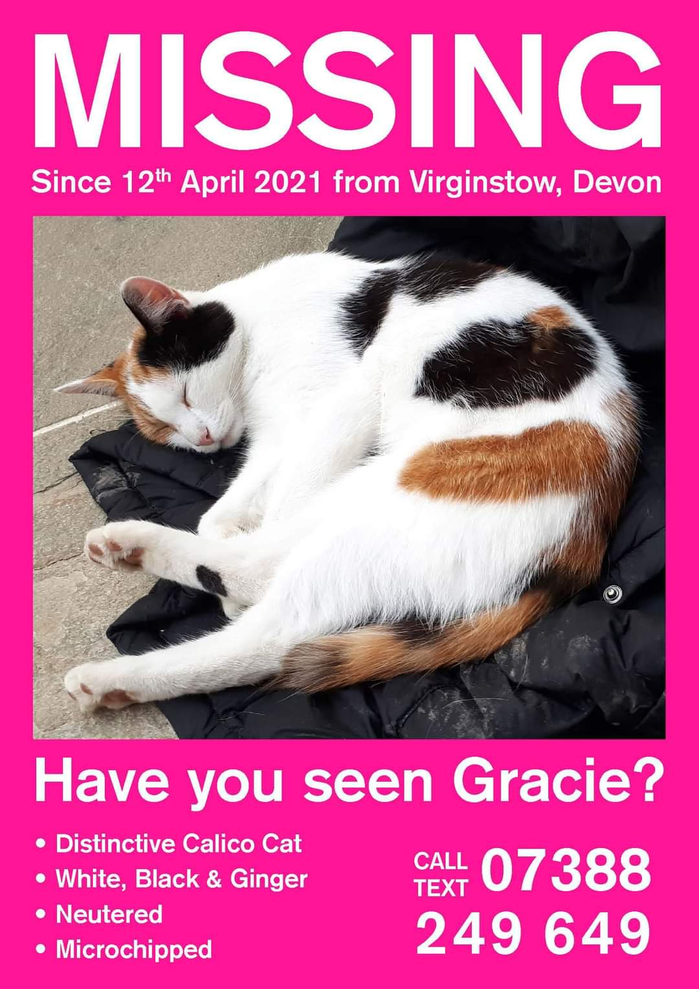

Friends of Germansweek Church:

Christmas Hamper Fundraiser

Please support the Friends of Germansweek Church by entering their draw for your chance to win Christmas Hampers full of goodies! Tickets are available at £1 per ticket or £5 per strip. The draw will now take place on the 20/12/21 (unfortunately not at the Carol Service as previously stated).
This is a great opportunity for you to support the village church, you may not often visit or attend services but appreciate its presence and historic value. Like any old building, the church requires upkeep and repair, by supporting the Friends fundraisers you are helping to ensure that the church will be maintained for the future.
Any donated items for the Hampers would be gratefully received and can be left in the church, at Lynne Moyse’s, Eworthy (01837 871149 / lynnemoyse@gmail.com) or by phoning Linda Tame on 01837 608208/ 07947104474 for collections. Please also contact them if you would like to purchase tickets which are now on sale! Tickets can also be purchased from Catherine Walker (07846830321) Gail Shinn (shinn5@btinternet.com / 871285) Keith Greenaway or Barbara Randall.
We look forward to your support and hope you buy the winning numbers!!
THANK YOU AND GOOD LUCK.

Roadford Lake Rowing Club Update:

Well, the weather has certainly given our rowing members a few challenging weekends recently, especially to our newer members, but how they have stepped up to that challenge! Well done to all.
The Club continues to grow, as well as settling into the weekly Club Days out on this fabulous lake that sits right on our doorstep. A great rowing venue alongside many other water sports.
Club Members have been busy off the water too! With Emergency First Aid & Coaching qualifications completed as well as visiting other clubs (Exeter, Exeter University & Christchurch) and applying for funding assistance. Every club needs funding help now and again!
In case we do not see you before 2022, we wish you all a Merry Christmas and our best too for a great New Year.

Ian Lamb
Park Cottage Eworthy
Ian.h.lamb@hotmail.co.uk
07837 190678

News from the Parish Council

Let’s celebrate it’s that time of the year! You are invited, courtesy of the parish council, to a singalong of Christmas songs and carols around our tree at the war memorial on December 4th, 6:15pm for 6:30pm, when our special guest will switch on the lights, with the Germansweek Singers and with the help of mulled cider or a nonalcoholic drink, it should be a fun evening. This event is free to all parishioners. Our thanks to DEVON HAMPERS of Lifton for giving us the cider. Please respect each other and remember to keep safe by being careful at this event. Note there is no public convenience open during this event.
AND……that’s not all ! Following the success of last year’s Quizmas we are repeating this event so all can be involved with searching out and answering the questions. The prize is a huge chocolate hamper so all correct answers will be entered in the final draw. The quiz is available at the Village Hall from December 6th to December 20th. Get out in your social bubble and enjoy the challenge in your own time, pace and convenience. Good luck!
Currently, the Council is working hard to get the books balanced ready to apply to WDBC for the 21/22 Precept. This is proving quite a challenge as costs have gone up, as have our legal responsibilities, so amicable discussions continue until we sign it off in December/ January.
Whilst you prepare for the celebrations please remember that salt is available from Cllr Lynne’s farm in Eworthy. It’s free so make sure you stay safe. Bags of salt have been placed at the known pinch points around the parish, our thanks go to Cllr Steve for checking the safety of the parish. Whilst on the subject of safety we are looking forward to Richard and Glynn visiting to clear the ditches…if there are any areas you know about please contact the Clerk so it can be put on the list. So far we have no date for their visit. This is also an ideal time of year to get any hedges trimmed on the roadside, as this is a legal requirement for all landowners and a great idea for a workout after the festivities to loose any weight gained!!! You have until March31st to get them sorted.
Finally the Councillors and Parish Staff wish you a very happy and peaceful Christmas and New Year. Safe aware and stay safe…. Jacky.

Devon Hampers are a local company and major local employer with premises at Dingles, Lifton. Very many thanks to them for donating the cider.

Upcoming/regular events or meetings;

Ivyhouse Garden Club (Broadwood). Please check www.nextdoor.co.uk for the next session . All welcome.

Saturday Evening 4th December, Christmas get together around the tree at Germansweek Village Hall, 6.30 pm.

Sing along round 2 hold sessions every month in Germansweek Church. This month 3rd December at 6pm in the church.
Germansweek Cribbage Social meets regularly every month. Check www.nextdoor.co.uk for regular updates and meetings.
Much more local information and events can be found on www.nextdoor.co.uk Please take some time to join up and keep up!

Contact Information:

Adrian Brook Parish Vicar 01837 861580

Jackie Theobald Parish Council Chair 01837 871446

Rachel Ward Parish Clerk Crane Cottage, Germansweek, EX21 5BA
germansweekpc@gmail.com

Germansweek Village Hall bookings; contact Eli Collins 01837 871317

Editor: wolfeditor@icloud.com

Please send your copies for inclusion. The deadline is 25th. of every month
Online copies to be found at www.germansweekpc.co.uk under ‘news’ tab

